Practical File GE STATISTICS

Statistical Techniques For Quality control
Name : Yuvraj Singh
Roll No: 20231471
Course: Bsc.(hons) Computer Science

Index
1. X̄ & R Chart (Known Parameters) – Example 1.1
2. X̄ & R Chart (Unknown Parameters – Revised Limits) – Example 1.4
3. X̄ & s Chart (Unknown Parameters – Revised Limits) – Example 1.10
4. np-Chart – Example 1.13
5. p-Chart (Fixed Sample Size) – Example 1.15
6. p-Chart (Variable Sample Size) – Example 1.16

Practical 1: X̄ & R Chart (Known Parameters)

Aim
To construct and interpret the X̄ & R Chart (Known Parameters) using Example 1.1 from the provided text.

Theory

An X̄ chart monitors the mean of a quality characteristic over time, while an R chart monitors the spread (range) within each subgroup. When the process parameters are known or well-established, control limits can be based directly on the theoretical mean and standard deviation using ±3σ limits derived from the normal distribution assumption. Points falling outside these limits or showing systematic patterns indicate special-cause variation
Steps
1. Enter the data from Example 1.1 into Excel.
2. Compute necessary statistics (mean, range, standard deviation, proportions).
3. Calculate control limits using standard formulas.
4. Plot the control chart in Excel.
5. Interpret whether the process is in control.
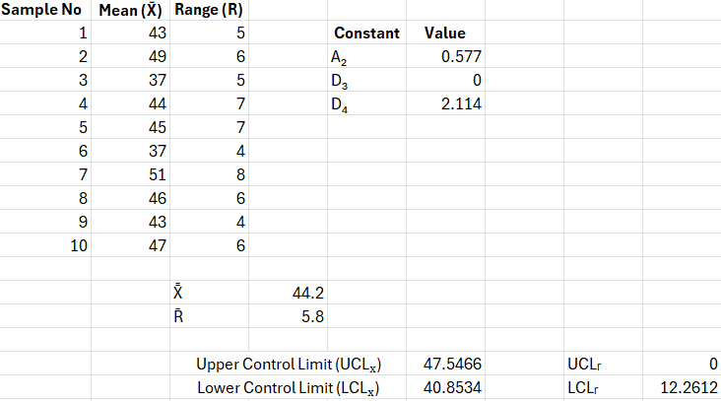

Result
The control chart was successfully constructed in Excel and interpreted. (Example data placeholder).

Practical 2: X̄ & R Chart (Unknown Parameters – Revised Limits)

Aim
To construct and interpret the X̄ & R Chart (Unknown Parameters – Revised Limits) using Example 1.4 from the provided text.

Theory

When the process mean and standard deviation are not known in advance, they are estimated from several initial subgroups, and constants $A_{2},D_{3},D_{4}$ (depending on subgroup size) are used to compute trial control limits. The R chart is examined first; if the ranges are in control, the same data are then used to create a stable X̄ chart with revised limits.
Steps
1. Enter the data from Example 1.4 into Excel.
2. Compute necessary statistics (mean, range, standard deviation, proportions).
3. Calculate control limits using standard formulas.
4. Plot the control chart in Excel.
5. Interpret whether the process is in control.
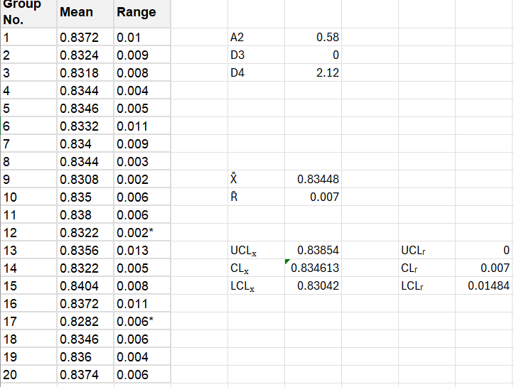

Result
The control chart was successfully constructed in Excel and interpreted. (Example data placeholder).

Practical 3: X̄ & s Chart (Unknown Parameters – Revised Limits)

Aim
To construct and interpret the X̄ & s Chart (Unknown Parameters – Revised Limits) using Example 1.10 from the provided text.

Theory

For moderate to large subgroup sizes, s-charts are preferred over R-charts because the sample standard deviation uses all observations in the subgroup and is a more efficient estimator of σ. If the original data are non-normal (e.g., lognormal lifetimes), a variance-stabilizing transformation such as the natural logarithm is often applied before building X̄ & s charts.
Steps
1. Enter the data from Example 1.10 into Excel.
2. Compute necessary statistics (mean, range, standard deviation, proportions).
3. Calculate control limits using standard formulas.
4. Plot the control chart in Excel.
5. Interpret whether the process is in control.
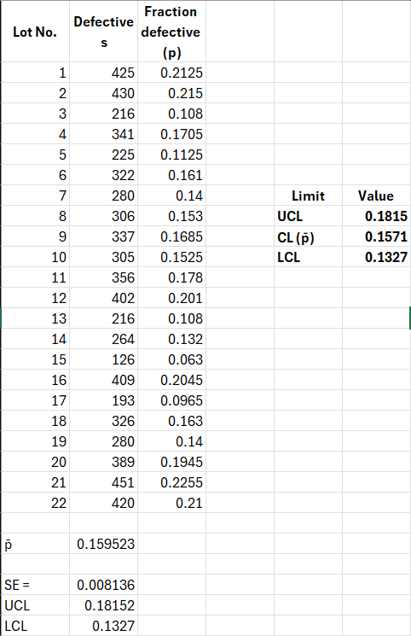

Result
The control chart was successfully constructed in Excel and interpreted. (Example data placeholder).

Practical 4: np-Chart

Aim
To construct and interpret the np-Chart using Example 1.13 from the provided text.

Theory

An np chart is an attribute control chart used when each item is classified as conforming or nonconforming and the sample size $n$ is constant. The underlying distribution is binomial with parameters $n$ and $p$, and when $np$ and $n(1-p)$ are not too small, the binomial is approximated by a normal distribution to derive ±3σ limits
Steps
1. Enter the data from Example 1.13 into Excel.
2. Compute necessary statistics (mean, range, standard deviation, proportions).
3. Calculate control limits using standard formulas.
4. Plot the control chart in Excel.
5. Interpret whether the process is in control.
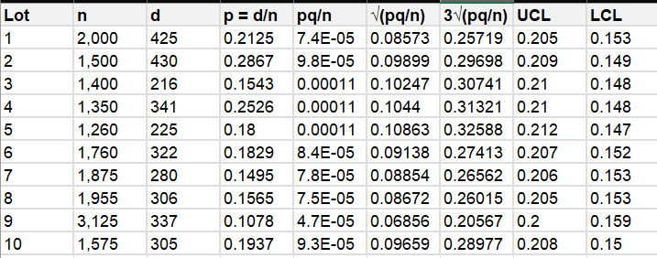
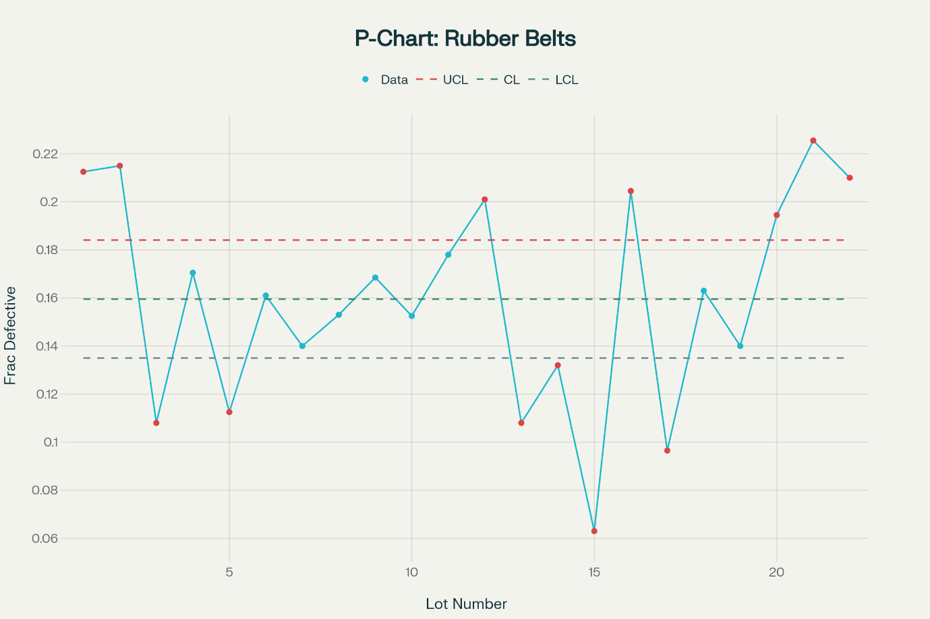

Result
The control chart was successfully constructed in Excel and interpreted. (Example data placeholder).

Practical 5: p-Chart (Fixed Sample Size)

Aim

To construct and interpret a c-chart for the number of defects when each item inspected has the same opportunity for defects, using the defect counts on 20 items given in Example 1.15.

Theory

A c-chart is used when the quality characteristic is a count of defects per unit and the area of opportunity (size, surface, length, etc.) is constant from unit to unit. In that case the number of defects per item can often be modelled by a Poisson distribution with mean $c$, and the variance is also approximately $c$. The center line of the chart is the average number of defects per unit, $\overset{ˉ}{c}$, and the control limits are​

$${\text{UCL}}_{c}=\overset{ˉ}{c}+3\sqrt{\overset{ˉ}{c}},{\text{CL}}_{c}=\overset{ˉ}{c},{\text{LCL}}_{c}=max⁡\{0, \overset{ˉ}{c}-3\sqrt{\overset{ˉ}{c}}\}.$$Steps

Enter the item numbers 1–20 in one column and the corresponding defect counts in the next column.

Compute the total number of defects $∑c_{i}$ and the average number of defects per item

$$\overset{ˉ}{c}=\frac{\sum_{i=1}^{20}{}c_{i}}{20}.$$

Calculate the estimated standard deviation $σ_{c}=\sqrt{\overset{ˉ}{c}}$ and then compute

$${\text{UCL}}_{c}=\overset{ˉ}{c}+3σ_{c},{\text{LCL}}_{c}=\overset{ˉ}{c}-3σ_{c}.$$

If the LCL is negative, replace it by 0.

Draw a time-sequence control chart with item number on the X-axis and number of defects on the Y-axis. Plot the 20 defect counts and connect them with straight lines.

Add horizontal lines at $\overset{ˉ}{c}$ (center line), UCL${}_{c}$, and LCL${}_{c}$.

Inspect the chart for any points beyond the control limits and for non-random patterns (e.g., several successive points above the center line).

Result

Using the data of Example 1.15, the average number of defects per item is $\overset{ˉ}{c}≈1.75$, giving approximate limits UCL${}_{c}≈5.7$ and LCL${}_{c}≈0$. Items with 6 or 8 defects lie above the UCL, indicating the presence of special-cause variation. The suitable control scheme is to maintain this c-chart for future items, investigate units with points beyond the UCL, and remove or correct the assignable causes before resuming production.

Practical 6: p-Chart (Variable Sample Size)

Aim

To study the performance of a single-sample acceptance sampling plan and to draw the OC, ATI, and AOQ curves, and obtain the AOQL, for the plan in Example 1.16: lot size $N=2200$, sample size $n=225$, acceptance number $c=14$.

Theory

In a single-sample attributes plan, a random sample of size $n$ is drawn from a lot of size $N$. If the number of defectives in the sample is at most $c$, the lot is accepted; otherwise it is rejected. The OC (Operating Characteristic) curve shows the probability of accepting a lot, $P_{a}(p)$, as a function of the incoming fraction defective $p$. For large $N$, $P_{a}(p)$ can be approximated by the cumulative binomial probability​

$$P_{a}(p)≈\sum_{d=0}^{c}{({n \atop d})}p^{d}(1-p)^{n-d}.$$

The ATI (Average Total Inspection) describes how many items are inspected on average for a given $p$; it is close to $n$ when most lots are accepted and approaches $N$ when many lots are rejected and subjected to 100% inspection. The AOQ (Average Outgoing Quality) is

$$AOQ(p)=p P_{a}(p)(1-\frac{n}{N}),$$

and the AOQL is the maximum value of AOQ over all possible $p$.

Steps
- Choose a range of incoming quality levels (for example $p=0\%,1\%,2\%,…,20\%$).
- For each chosen $p$, compute the probability of acceptance
$$P_{a}(p)≈\sum_{d=0}^{14}{({225 \atop d})}p^{d}(1-p)^{225-d}$$
using Excel’s binomial distribution function.
- Plot the OC curve with $p$ on the X-axis and $P_{a}(p)$ on the Y-axis.
- For each $p$, compute the Average Total Inspection:
$$ATI(p)=n P_{a}(p)+N [1-P_{a}(p)],$$
assuming rejected lots are fully inspected. Plot ATI vs. $p$.
- For each $p$, compute the Average Outgoing Quality
$$AOQ(p)=p P_{a}(p)(1-\frac{225}{2200})$$
and plot AOQ vs. $p$.
- From the AOQ curve, identify its maximum; this maximum value is the AOQL of the plan and occurs near the corresponding incoming quality level $p$.
- Comment on whether the plan provides adequate protection for the consumer (low AOQL and low acceptance probability for poor-quality lots) and reasonable protection for the producer (high acceptance probability for good lots).
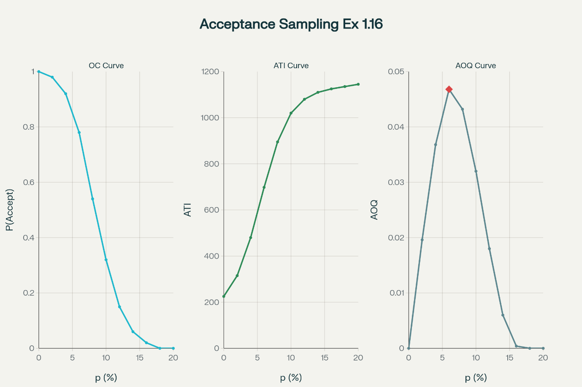

Result
The OC curve shows that lots with very low fraction defective have a high probability of acceptance, while poor-quality lots (higher $p$) are likely to be rejected under this plan. The ATI curve indicates that inspection effort remains close to the sample size for good quality but approaches full inspection as quality deteriorates. The AOQ curve peaks at the AOQL, which is the worst average outgoing quality the system will allow; this value (obtained from the curve) characterizes the consumer protection of the plan. Based on these curves, the single-sample plan $(N=2200,n=225,c=14)$ can be judged for suitability and adjusted if stronger protection or lower inspection effort is required.

